TABLE OF CONTENTS

Project Overview ......................................................................................................... 1
1.1 Game Concept Summary ..................................................................................... 1
1.2 Target Platform & Minimum Specifications ....................................................... 2

Tools & Technology ................................................................................................... 3
2.1 Game Engine ...................................................................................................... 3
2.2 Programming Language ..................................................................................... 3
2.3 IDEs & Assets .................................................................................................... 4
2.4 External Services ............................................................................................... 4

Installation & Setup ................................................................................................... 5
3.1 Prerequisites ...................................................................................................... 5
3.2 Opening the Project .......................................................................................... 6
3.3 Running in Unity Editor ................................................................................... 6
3.4 Running on Device / Build ............................................................................... 7

Architecture & Code Walkthrough …………………………………........................ 8
4.1 System Architecture Overview .......................................................................... 8
4.2 Folder Structure ................................................................................................. 9
4.3 Key Scripts ....................................................................................................... 10
4.4 Data Storage ..................................................................................................... 11

Game Design & User Interface ............................................................................... 12
5.1 Core Mechanics ............................................................................................... 12
5.2 UI Flow ............................................................................................................ 13
5.3 Asset Attribution ……………………………….............................................. 14

Art & Sound Pipeline ............................................................................................. 15
6.1 Asset Optimization ......................................................................................... 15
6.2 Naming Conventions ...................................................................................... 16
6.3 Replacing Assets ............................................................................................ 16

Deployment & Release Notes ................................................................................ 17
7.1 Deployment .................................................................................................... 17
7.2 Release Notes ................................................................................................. 18
7.3 Licensing ........................................................................................................ 18

Future Work ........................................................................................................... 19

Appendices ............................................................................................................ 20
Appendix A – Key Code Snippets ....................................................................... 20
Appendix B – Development Milestones ............................................................. 22
Appendix C – Asset Attribution & Tools ............................................................ 24
Appendix D – External Links & Citations .......................................................... 25

Step-by-Step Guide in Creating the 2D Game (Gnome’s Well) ……………....... 26
10.1 Development Tools Installation .................................................................. 26
10.2 Project Creation ........................................................................................... 27
10.3 Asset Preparation & Organization ............................................................... 28
10.4 Prototype Object Creation ........................................................................... 29
10.5 Sprite Setup & Hierarchy ............................................................................ 30
10.6 Rigidbody & Collider Configuration ........................................................... 31
10.7 Joint & Rope System Setup ......................................................................... 33
10.8 Input, Camera, and UI Setup ....................................................................... 36
10.9 Gameplay Script Integration ........................................................................ 38
10.10 Traps, Treasure & Exit Setup ..................................................................... 41
10.11 Art, Physics & Prefab Updates ................................................................ 45
10.12 Level Construction .................................................................................. 48
10.13 Menu Screens & Scene Management ..................................................... 50
10.14 Sound Effects Integration ....................................................................... 52

1. Project Overview
1.1 Game Concept Summary
The game focuses on rope physics gameplay. The player swings a gnome using a rope, avoids hazards, collects a treasure chest, and exits the level to win.
- Target Platform & Minimum Specs
- Platforms: Windows PC, Android
- Minimum Specs:
  - OS: Windows 10 / Android 8+
  - RAM: 8 GB
  - Storage: 1 GB

2. Tools & Technology
1. Engine
- Unity 6.2 (6000.2.2f1)
2. Language
- C#
3. IDEs & Assets
- Unity Editor
- Unity Hub
- Assets and scripts from Mobile Game Development with Unity (Packt, 2015)
4. External Services
- None (offline prototype)

3. Installation & Setup (Step-by-Step)
3.1 Prerequisites
- Install Unity Hub
- Install Unity Editor version 6.2 (6000.2.2f1)
3.2 Opening the Project
- Open Unity Hub
- Click Add Project
- Select the project folder
- Open the project
- If prompted, choose Open in Current Version
3.3 Running in Editor
- Open Assets/Scenes/Main.scene
- Click the Play button
3.4 Running on Device / Build
- Open File → Build Settings
- Select target platform
- Click Build and Run

- Architecture & Code Walkthrough

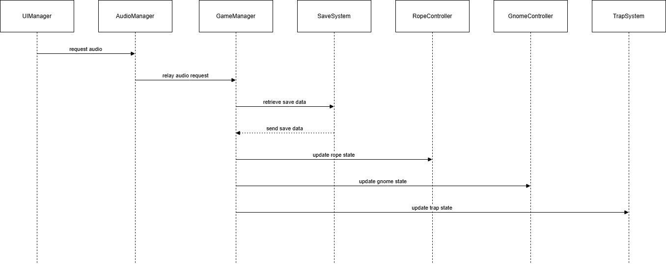
Figure 4.1 Architecture Diagram Description
Figure 1.0 shows the high-level architecture of Gnome’s Well. The GameManager serves as the central controller responsible for managing game states and coordinating all subsystems. Input, physics, UI, audio, traps, and data persistence are implemented as independent modules that communicate with the GameManager through public methods and event-driven callbacks.
4.2 Folder Structure
- Assets/Scripts – Game logic
- Assets/Scenes – Main scene
- Assets/Sprites – 2D graphics
- Assets/Sounds – Sound effects
4.3 Key Scripts
- GameManager.cs – Controls game state
- Rope.cs / RopeSegment.cs – Rope physics
- KillGnome.cs – Death logic
- Treasure.cs – Treasure collection
- Exit.cs – Win condition
- MenuManager.cs – Menus and pause
4.4 Data Storage
- No persistent save system
- Runtime-only data

5. Game Design & UI
5.1 Core Mechanics
- Rope swinging
- Rope extension/retraction
- Trap collision
- Treasure collection
5.2 UI Flow
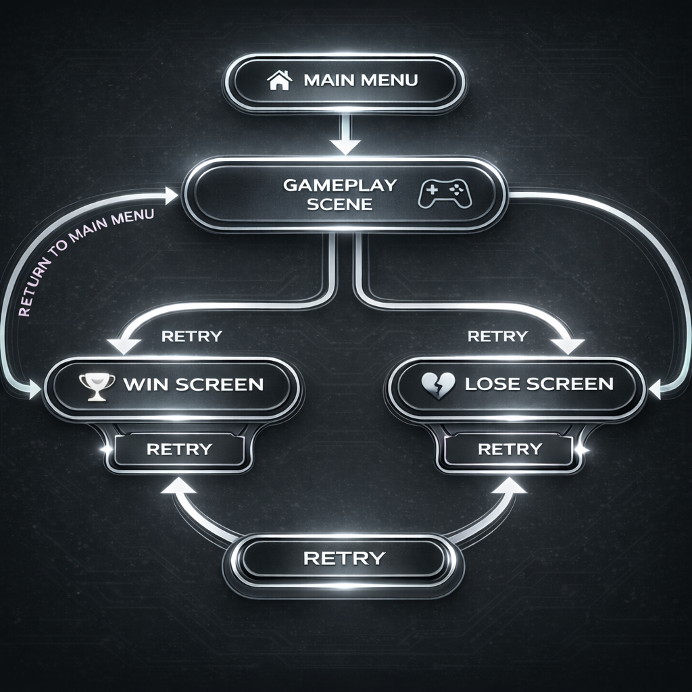
Figure 5.2 UI Flow Diagram Description
The UI flow diagram begins with the Main Menu, leading to the Gameplay Scene. From gameplay, the player transitions to either a Win Screen or Lose Screen, with options to retry or return to the Main Menu.
5.3 Asset Attribution
Assets from Mobile Game Development with Unity (educational use)

6. Art & Sound Pipeline
6.1 Asset Optimization
- 2D sprites optimized for resolution
6.2 Naming Conventions
- gnome_head.png
- rope_segment.png
6.3 Replacing Assets
- Import new asset
- Replace sprite in prefab
- Save changes

7. Deployment & Release Notes
7.1 Deployment
- Built locally for testing
7.2 Release Notes
- Initial prototype
- One playable level
7.3 Licensing
- Educational use only

8. Future Work
- More levels
- Improved rope physics
- Scoring system

9. Appendices
Appendix A. Key Code Snippets (Logic Overview)

- Rope Control Logic

// Conceptual logic for extending/retracting the rope
void Update() {
if (Input.GetKey(KeyCode.DownArrow)) {
ExtendRope(ropeSpeed * Time.deltaTime); // [cite: 14]
} else if (Input.GetKey(KeyCode.UpArrow)) {
RetractRope(ropeSpeed * Time.deltaTime); // [cite: 14]
}
}

- Tilt Movement Logic

// Conceptual logic for dodging traps using accelerometer
void FixedUpdate() {
float tilt = Input.acceleration.x;
transform.Translate(tilt * moveSpeed, 0, 0); // [cite: 15]
}

Appendix B. Development Milestones

Phase | Tasks | Status
Research | Market analysis of physics games like Cut the Rope. | Completed
Design | Wireframing in Canva; defining “mischievous” art style. | Completed
MVP Step 1 | Movement mechanics for gnome and rope. | Completed
MVP Step 2 | Implementation of traps and treasure objects. | Completed
Testing | Device compatibility and peer review (classmates). | Completed

Appendix C: Asset Attribution & Tools

A summary of the resources used to build the game environment and mechanics.
- Platform: Android OS.
- Engine: Unity.
- UI/UX Design: Canva.com.
- Physics Style: Ragdoll physics with 2D animations.
- Visual Themes: Cartoonish, colorful, and playful.

Appendix D: External Links & Citations
- Unity Documentation: Unity Physics 2D
- Market Inspiration: Cut the Rope and Happy Wheels.
- Project Repository: GitHub – DreamCatcher07/PEBSIT004_GnomeOnARope_LiwanagTrishea_JosefAngela_AnchetaAJ
References
- Valente, F. S. Mobile Game Development with Unity, 2015

10. STEP BY STEP GUIDE IN CREATING 2D GAME (GNOME’S WELL)
0. Development Tools Installation
The executable installers for Unity and Visual Studio Code were downloaded and installed on the system. Unity version 6.2 (6000.2.7f2) was then installed together with the required components, including Web Build Support, the Android SDK, and other necessary dependencies.

- Project Creation
Unity Hub was opened, and a new project was created using the 2D template. The project was then renamed to “Gnome’s Well1.”
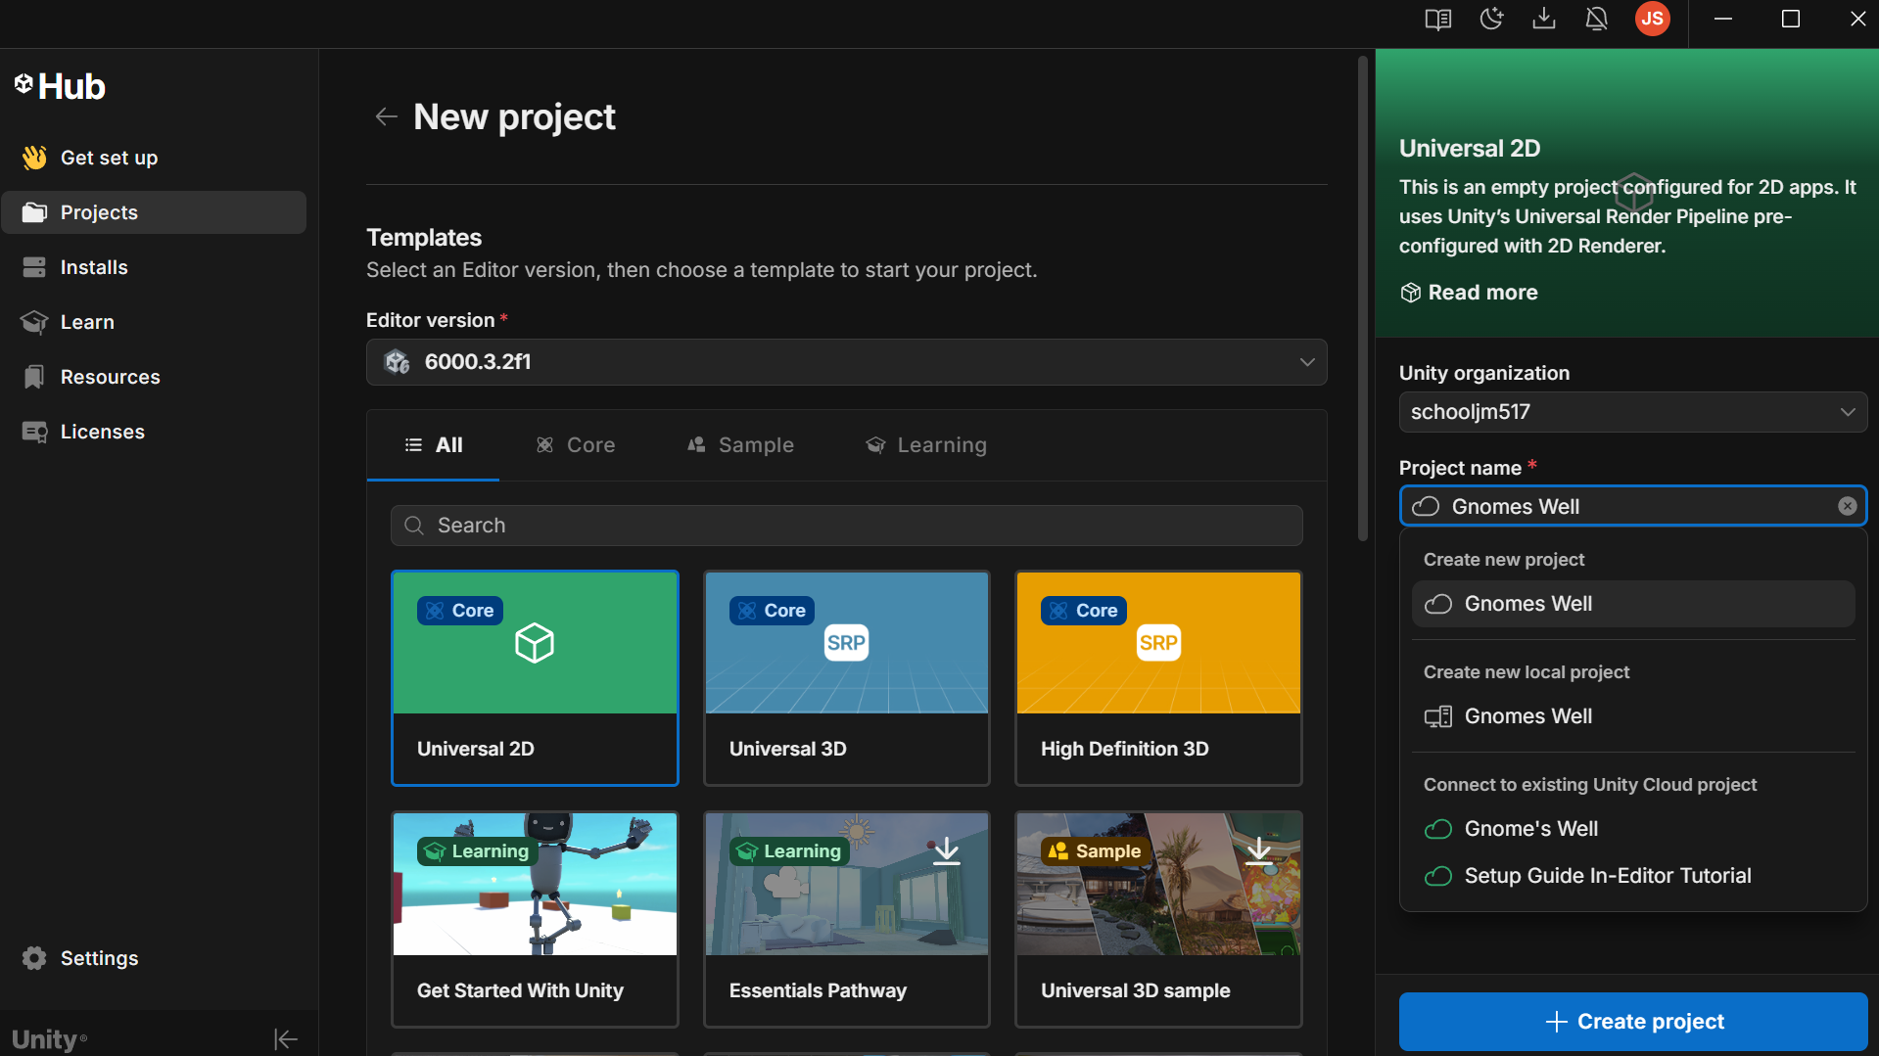
2. Asset Preparation and Organization
A ZIP file was downloaded from Secretlab.com, and the 2D Game folder was selected. From the extracted files, the Assets folder was located, and the Sprites and Sounds folders were copied into the project’s Assets directory.
Inside the project’s Assets folder, additional folders were created to organize resources, including Scripts, Gnome, Level, and App Resources. This was done by locating the project folder on the system and pasting the extracted sprite and sound files into the appropriate directories.
3. Prototype Object Creation
A prototype gnome object was created by opening the GameObject menu and selecting Create Empty. The object was then renamed “Prototype Gnome.”

4. Sprite Setup and Hierarchy Arrangement
The required sprites were added to the scene, including the prototype arm holding, prototype arm loose, prototype body, prototype head, prototype leg dangle, and prototype leg rope. All sprites were then set as child objects of the Prototype Gnome object. The sprites were positioned accordingly so that the character appears in an inverted orientation.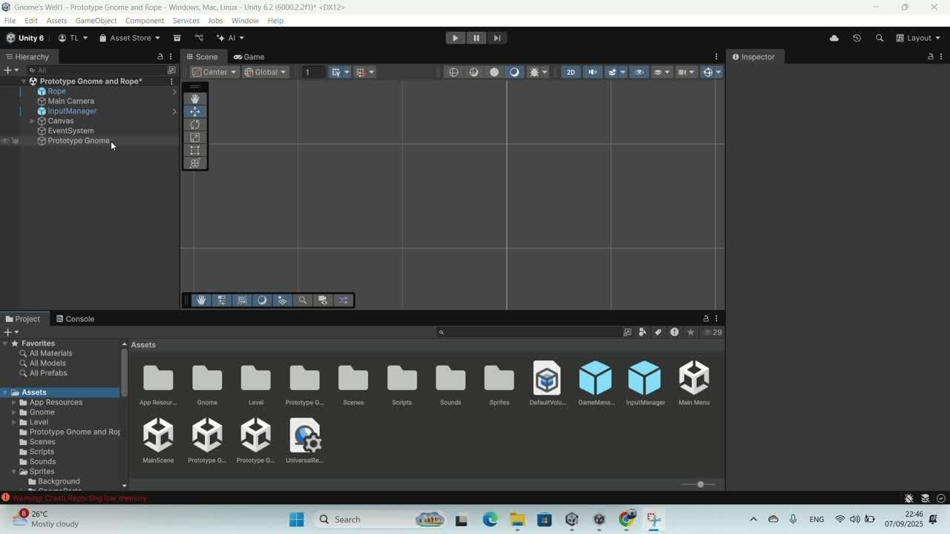
5. Rigidbody Configuration
All body part sprites were selected, and a Rigidbody2D component was added to each object through the Inspector panel.

6. Collider Assignment
Colliders were added to the body part sprites using the Inspector panel. BoxCollider2D components were assigned to the arm and leg sprites. A CircleCollider2D component was added to the head sprite. Another CircleCollider2D component was added to the body sprite, with the collider radius adjusted to properly fit the body.
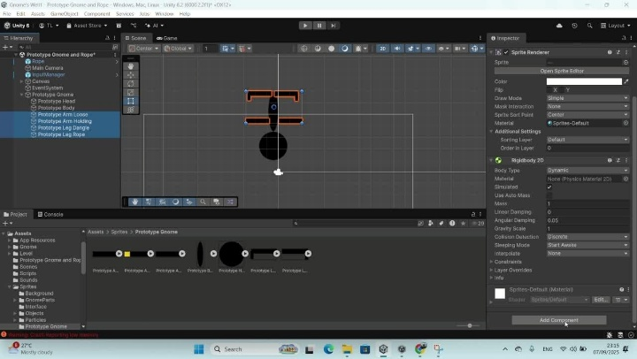
7. Joint Configuration
All sprites except the body were selected, and a HingeJoint2D component was added to each selected sprite. The Prototype Body object was then dragged from the Hierarchy panel into the Connected Rigidbody field in the Inspector panel.
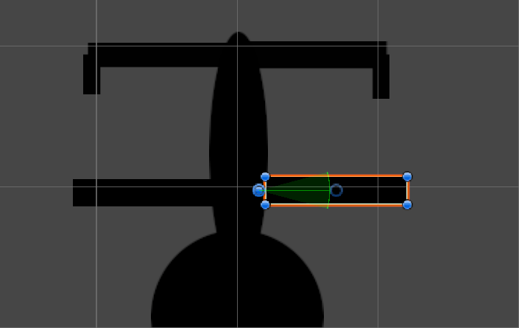
8. Joint Limit Settings
The arm and head sprites were selected, and the Use Limits option was enabled. The Lower Angle was set to -15, and the Upper Angle was set to 15.
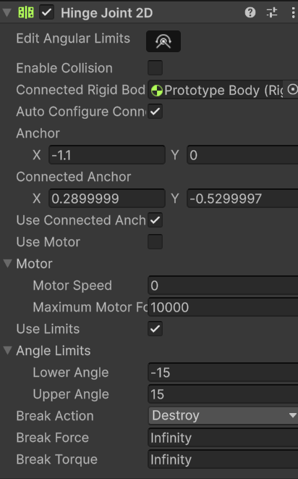
The leg sprites were then selected, the Use Limits option was enabled, and the Lower Angle was set to -45, while the Upper Angle was set to 0.
9. Joint Position Adjustment
The joint anchor positions were adjusted to ensure proper articulation. Both arms were connected at the shoulders, both legs were connected at the hips, and the head was connected at the base of the neck.

10. Spring Joint Setup
The Prototype Leg Rope sprite was selected, and a SpringJoint2D component was added. The Auto Configure Distance option was disabled, the Distance was set to 0.01, and the Frequency was set to 5.
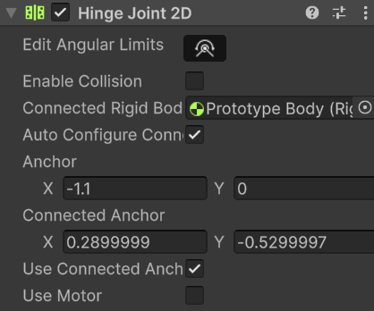
11. Rope Segment and Rope Object Creation
A Rope Segment object was created, and a Rigidbody2D component was added with the mass set to 0.5. A SpringJoint2D component was also added, with the Damping Ratio set to 1 and the Frequency set to 30. The object was then converted into a prefab, after which the original rope segment object was deleted from the scene. 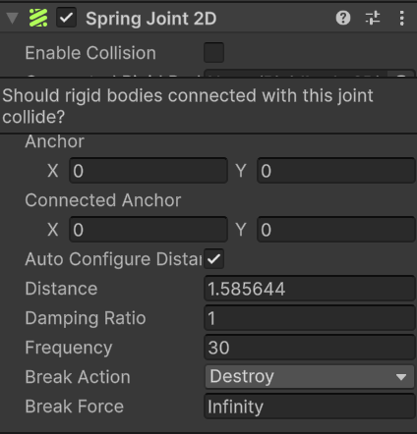

A new empty GameObject named “Rope” was created. Its icon was changed to a red rounded-rectangle shape for easy identification. Two components were added: Rigidbody2D and Line Renderer. The Rigidbody2D body type was set to Kinematic, and the Line Renderer width was set to 0.075 to visually resemble a rope.
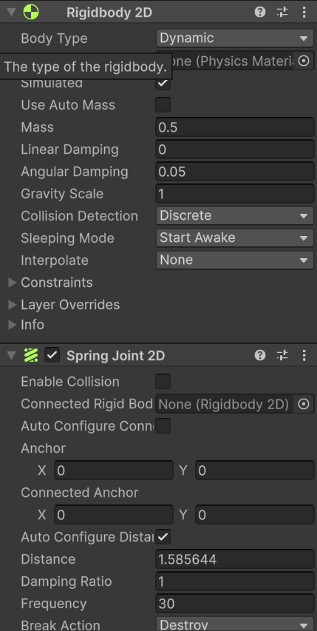
12. Rope Script and Material Setup
A script component was added to the Rope object, and the rope settings were configured in the Inspector panel. A new material named “Rope” was created, and its color was set to brown. After completing the setup, the project was executed to test the rope behavior.
13. Unity Remote Installation
The Unity Remote application was downloaded and installed from the Google Play Store on a mobile device to allow testing of the gnome game on the device.
14. Singleton Script Creation
A new empty C# script was created by selecting Create > Scripting > C# Script and was named “Singleton.” The provided code from the module was then pasted into the script.
15. Input Manager Setup
An empty GameObject named “InputManager” was created. An InputManager.cs script was also created, and the code provided in the module was pasted into the script. The script was then attached to the InputManager object.
16. Swinging Script Assignment
The Prototype Body object was selected, and a new script named “Swinging.cs” was created and attached to it. The corresponding code from the module was pasted into the script and configured through the Inspector panel.
17. UI Button Configuration
A UI button was added by selecting GameObject > UI > Button and was named “Down.” The button was positioned at the bottom-right corner of the screen, and its text label was changed to “Down.”
An Event Trigger component was added to the button, and a Pointer Down event was configured. The Rope object’s isIncreasing function was linked to this event by dragging the Rope object into the object field and selecting the appropriate function. The same procedure was repeated for the Up button.
18. Camera Follow Script Setup
A camera-follow script was added by creating a new component named “CameraFollow.” The provided code from the module was inserted into the script. The script uses the LateUpdate method to ensure smooth camera movement.
19. Gameplay Script Integration
Three scripts were added to the project:
- BodyPart.cs for managing limb behavior and damage effects
- Gnome.cs for controlling the overall behavior of the gnome
- RemoveAfterDelay.cs for automatically removing objects after a specified delay
The BodyPart component was attached to each limb of the gnome.
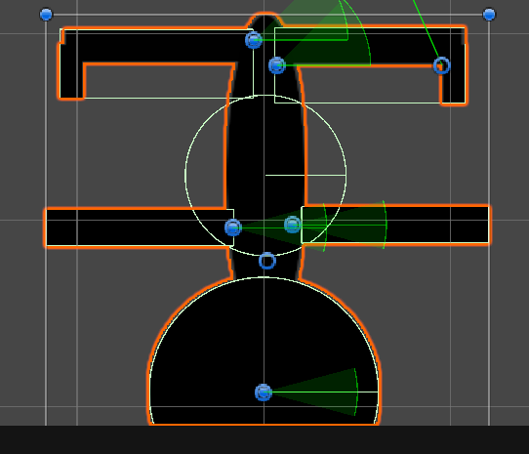
20. Bloody Fountain and Gnome Configuration
An empty GameObject named “Bloody Fountains” was created, along with child objects representing the head, legs, and other body parts. The gnome settings were then configured by attaching the Gnome.cs script to the Prototype Gnome object. The Prototype Body was assigned to the Camera Follow Target, the Prototype Leg was assigned to the Rope Body slot, and other required references were set in the Inspector panel.
21. Game Manager Setup and Final Integration
A GameManager object was created from the Hierarchy, and the GameManager.cs and Resettable.cs scripts were attached. The Game Manager controls the overall game flow, including gnome spawning, resetting after death, and menu display.
A Start Point object was created, the gnome was converted into a prefab, and all required references were linked in the Inspector panel. At this stage, the gnome can swing using tilt controls, climb the rope, and the Game Manager successfully manages all core gameplay functions.

22. Signal-on-Touch Script Creation
A script was created to detect when the player interacts with objects such as traps, treasure, or the exit. In the Project window, Assets > Create > C# Script was selected, and the script was named SignalOnTouch.cs. The script was opened, its default contents were removed, and the exact code provided in the reference book was inserted. The script was then saved and returned to Unity. This script sends a signal whenever the Player touches an object.
23. Trap (Spikes) Setup
The first trap was added by navigating to Sprites/Objects in the Project window and dragging SpikesBrown into the Scene. A PolygonCollider2D component was added, followed by attaching the SignalOnTouch script.
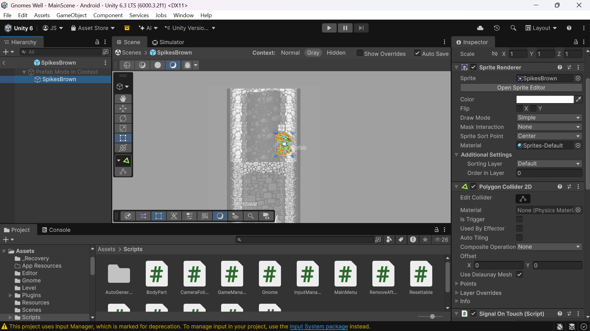
In the On Touch event, the GameManager object was assigned, and the function GameManager.TrapTouched was selected. This configuration causes the gnome to take damage when it touches the spikes. The configured SpikesBrown object was then dragged into the Level folder to create a reusable prefab.
24. Exit Setup
The exit was added at the top of the well by dragging the Top sprite from Sprites/Background into the Scene and positioning it just below the rope. A BoxCollider2D was added and set as a trigger. The collider was resized to cover the top exit area.
The SignalOnTouch script was added, and its On Touch event was configured to call GameManager.ExitReached. This allows the Game Manager to detect when the gnome reaches the exit.
25. Treasure Setup
A new script named SpriteSwapper.cs was created and populated with the code provided in the reference book. This script allows sprite changes, such as switching from a present treasure to a collected state.
The TreasurePresent sprite was dragged into the Scene near the bottom of the well. A BoxCollider2D was added and set as a trigger. The SpriteSwapper component was added, and TreasureAbsent was assigned as the replacement sprite. The Treasure’s Sprite Renderer was also linked.
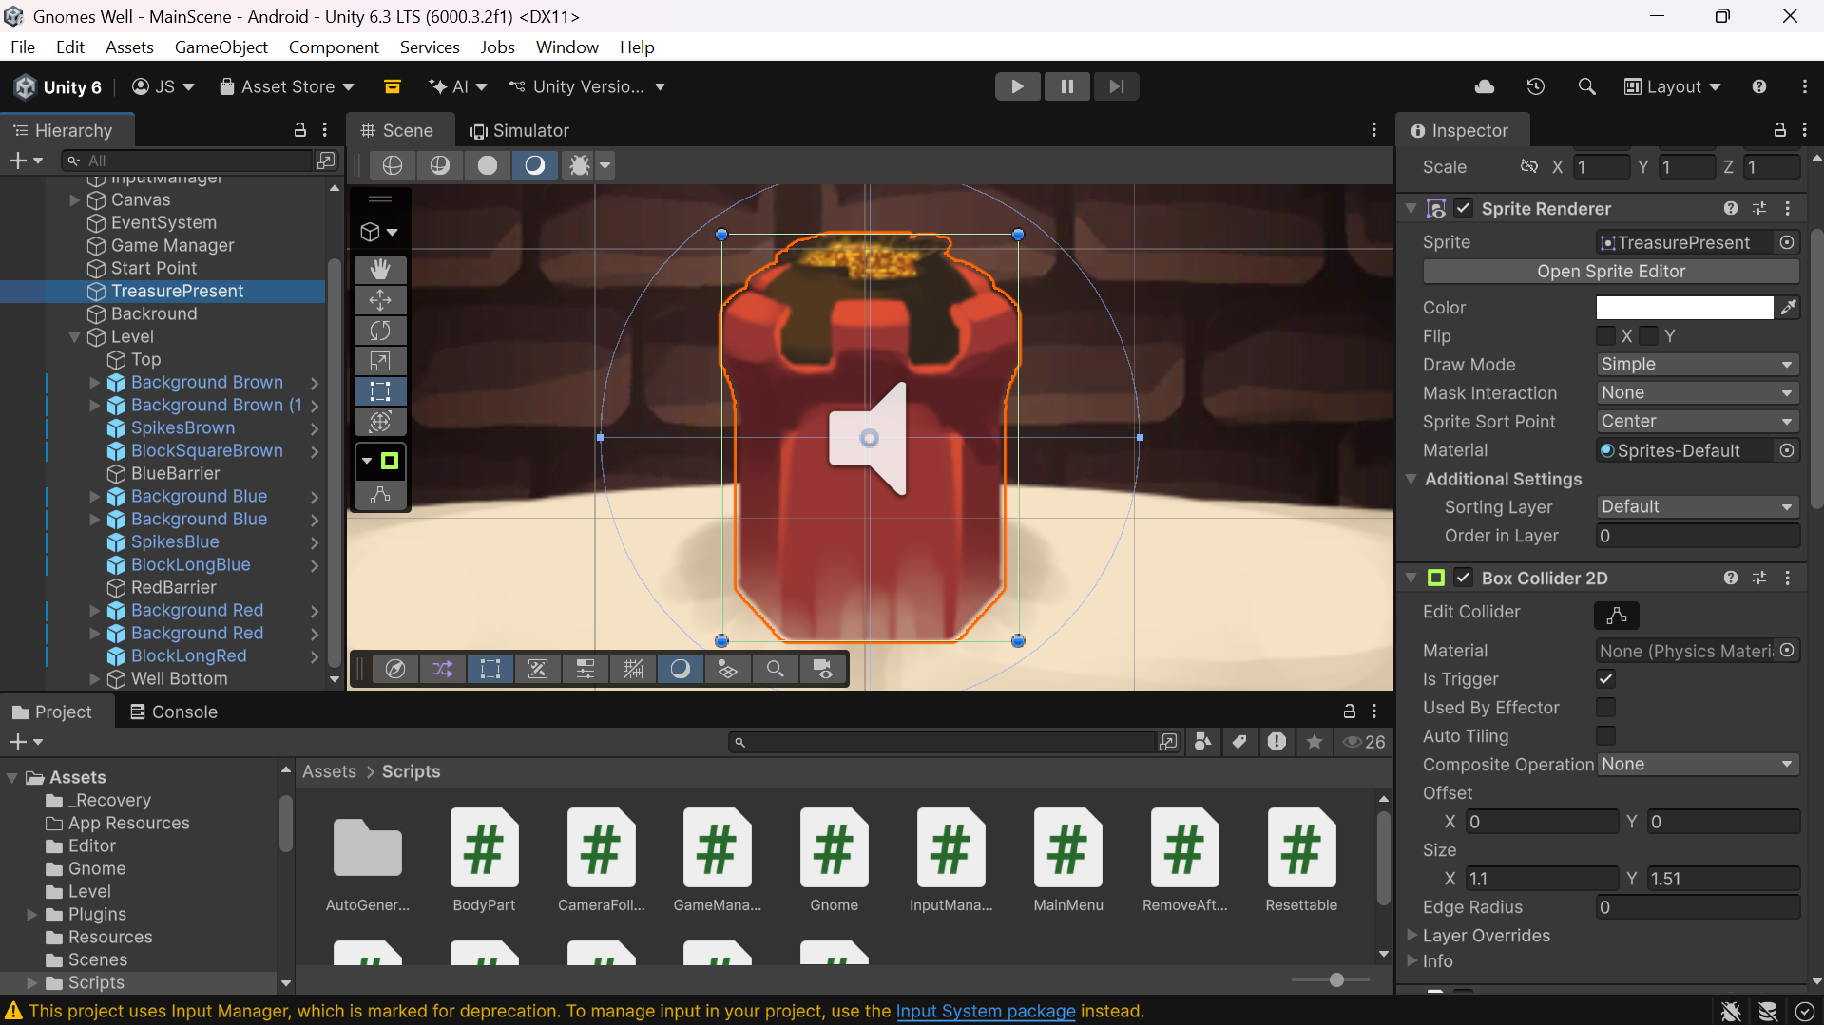
The SignalOnTouch script was added with two events:
- GameManager.TreasureCollected
- SpriteSwapper.SwapSprite
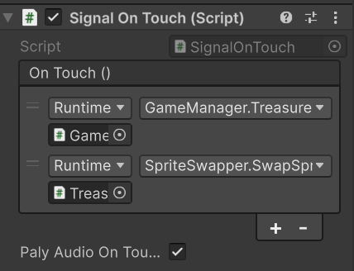
A Resettable component was added, and SpriteSwapper.ResetSprite was assigned to reset the treasure after death.
26. Treasure Testing
When the gnome touches the treasure, the treasure disappears and notifies the Game Manager. If the gnome dies, the treasure resets. The feature was tested to confirm correct behavior.
27. Background Placeholder Setup
A placeholder background was added by selecting GameObject > 3D Object > Quad and naming it Background. Its Z Position was set to 10 to place it behind all objects. Using the Rect Tool, the quad was resized to span from the exit at the top to the treasure at the bottom, resulting in a clean gray background.
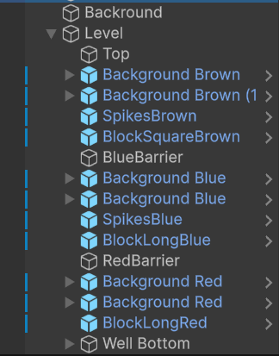
28. Gnome Art Update
The gnome’s artwork was updated using assets from the GnomeParts folder, which contains Alive and Dead sprite sets. All sprites in the Alive folder were selected, and their Texture Type was set to Sprite (2D and UI).
29. Pivot Point Adjustment
Using the Sprite Editor, pivot points were adjusted for all sprites except the body. Each pivot was placed at the joint rotation point, such as the shoulder for arms. This process was repeated for all gnome parts except the body.
30. Gnome Prefab Update
The prototype gnome prefab was dragged into the Scene and renamed Gnome. Each body part sprite was replaced with the updated Alive sprites and repositioned for better visual alignment.
Sorting orders were set as follows:
- Head and Arms: Order in Layer = 2
- Body: Order in Layer = 1
31. Physics Update
Existing colliders were removed from the arms, legs, and head. PolygonCollider2D components were added and adjusted to match each sprite’s shape. The body’s CircleCollider2D radius was increased to 1.2.
Joint anchors and connected anchors were repositioned to match pivot points, such as the neck and shoulders.
32. Final Gnome Configuration
The second joint anchor of the leg rope was moved to the ankle. Arm-holding sprites were assigned in the Gnome script. The gnome scale was set to X = 0.3 and Y = 0.3, changes were saved to the prefab, and the Scene instance was removed. The updated gnome prefab was assigned to the GameManager and tested.
33. Sorting Layer Setup
New sorting layers were created: Level Background, Level Objects, and Level Foreground.
34. Level Background Construction
An empty Level GameObject was created. Background objects (Brown, Blue, and Red variants) were organized as children, sorted correctly, duplicated, rotated, and scaled to construct a long vertical level. Barriers were placed between sections.
35. Well Bottom Setup
An empty GameObject named Well Bottom was created. The bottom sprite and sandy side walls were added, and the treasure was repositioned to the center of the sand dune.
36. Camera Adjustment
The Main Camera’s Orthographic Size was set to 7, the top limit to 11.5, and the bottom limit adjusted based on well depth.
37. UI Setup
Interface sprites were imported and set to Pixels Per Unit = 2500, except for the “You Win” sprite. The Up and Down buttons were updated by removing text children, assigning sprites, resizing, and repositioning. A Gameplay Menu object was created to contain the buttons.
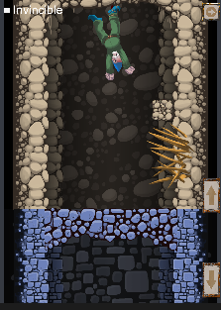
38. Menu Screens Setup
A Game Over screen was created with a “You Win” image and a New Game button linked to GameManager.RestartGame(). A Pause Menu and Main Menu were also added with appropriate button connections.
39. Invincibility Debug Mode
A Debug Menu was created with a toggle named Invincible, connected to GameManager.gnomeInvincible. When enabled, the gnome does not die from traps.
40. Themed Spikes Creation
The SpikesBrown prefab was duplicated to create SpikesBlue and SpikesRed. Sprites were updated, and polygon colliders were reset. The new spikes were placed in the Scene for testing.
41. Spinning Blade Trap Setup
A spinning blade trap was created using SpinnerArm, SpinnerBladesClean, and SpinnerHubcap sprites, properly layered and positioned.
42. Spinner Damage Configuration
A CircleCollider2D and SignalOnTouch script were added to the blades, configured to call GameManager.TrapTouched.
43. Spinner Animation Setup
An Animator component was added, along with a controller and spinning animation. A script was used to enable animation control.
44. Block Prefabs Creation
Blue, Red, and Brown block sprites were added, assigned BoxCollider2D, and converted into prefabs.
45. Blood Material Setup
A blood texture was configured, and a Blood material was created using an Unlit/Transparent shader.
46. Blood Fountain Effect
A particle system named Blood Fountain was created, configured, and saved as a prefab.
47. Blood Explosion Effect
A Blood Explosion particle system was created with burst emission and automatic removal. Both blood effects were assigned to the Gnome prefab.
48. Main Menu Scene Creation
A new scene named Menu was created with a background image properly anchored and scaled.
49. New Game Button Setup
A New Game button was added, positioned, and labeled accordingly.
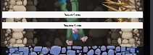
50. Loading Overlay Setup
A Loading Overlay was created with a semi-transparent background and centered “Loading…” text.
51. Scene Loading Configuration
A loading script was attached to the Main Camera. Scene order was configured in Build Settings, allowing smooth transition from menu to gameplay.
52. Sound Effects Integration
Audio sources were added to spikes, spinner traps, treasure, and the Game Manager. Appropriate sound clips were assigned, completing the audio setup.

